

Department of Systems

School Of Computer Science

UNIVERSITY OF PETROLEUM & ENERGY STUDIES,

DEHRADUN- 248007, Uttarakhand

**School of Computer Science**

            University of Petroleum & Energy Studies, Dehradun

**BLOG-HIVE**

Submitted By-

| **Specialization** | **SAP ID** | **Name** |
| --- | --- | --- |
| **B.Tech CSE CCVT** | **500091766** | **MANAV VERMA** |

**Cloud Platform Selection**

1. **Managed Kubernetes Service (Amazon EKS):**

AWS offers a fully managed Kubernetes service called Amazon EKS. This service eliminates the need for you to manage the underlying infrastructure and nodes.

With EKS, you can easily deploy, manage, and scale containerized applications using Kubernetes without the operational overhead of maintaining the Kubernetes control plane.

**2. Integration with Other AWS Services:**

AWS provides a comprehensive suite of services that seamlessly integrates with each other. For a microservices architecture, you might need additional services like Amazon RDS for databases, Amazon S3 for storage, and Amazon Cognito for user authentication. AWS services work well together, providing a cohesive environment for your application.

**3. Auto-Scaling and High Availability:**

AWS EKS can automatically scale your worker nodes based on demand. This ensures high availability and efficient resource utilization.

Auto Scaling Groups (ASGs) can be configured to dynamically adjust the number of nodes in your EKS cluster based on factors like CPU utilization or custom metrics.

**4. Security and Compliance:**

AWS provides a range of security features, including Virtual Private Cloud (VPC) for network isolation, Identity and Access Management (IAM) for fine-grained access control, and Key Management Service (KMS) for encryption.

Compliance certifications such as ISO, SOC, and HIPAA make AWS suitable for projects with strict security and compliance requirements.

**5. Ecosystem and Marketplace:**

AWS has a rich ecosystem of partners and a vast marketplace where you can find pre-built solutions and integrations. This can accelerate development and reduce the time to market for BlogHive.

Third-party tools and services, such as monitoring and logging solutions, are readily available for AWS environments.

**Container Orchestration**

**1. Containerize Microservices with Docker:**

Each microservice is containerized using Docker. This involves creating Docker images for each microservice, specifying dependencies, and encapsulating the application and its dependencies in a portable container.

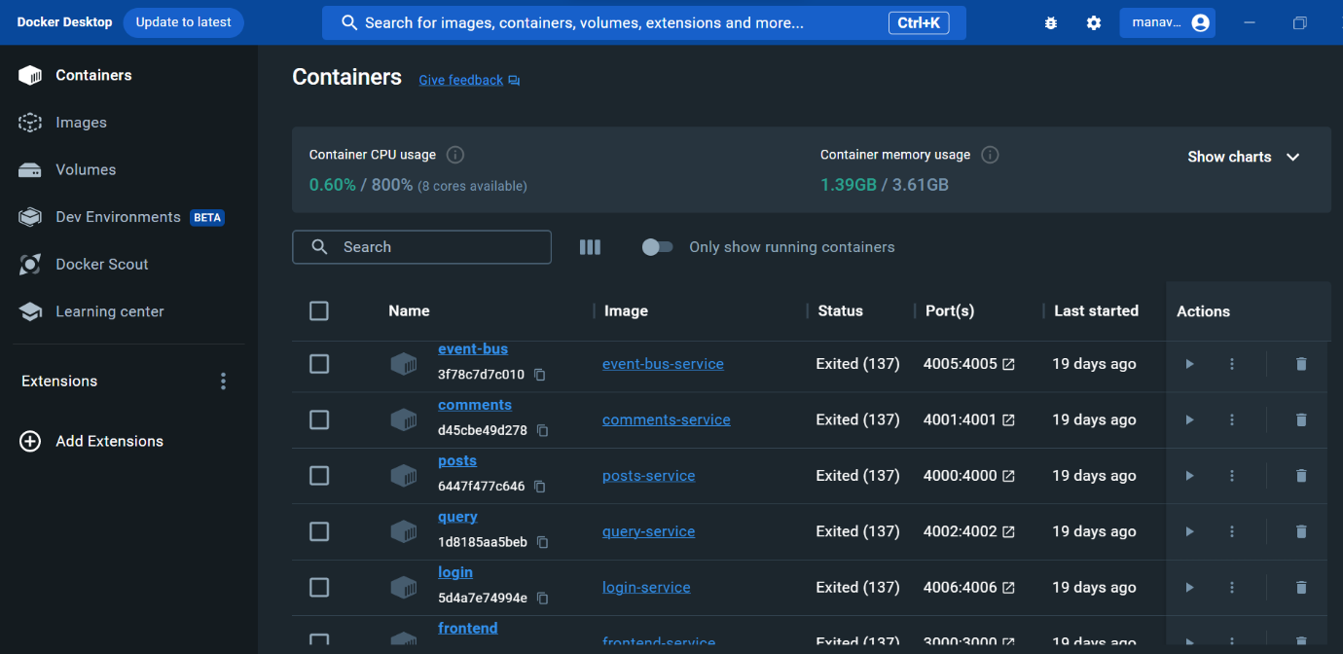

**2. Define Kubernetes Deployments:**

Kubernetes Deployment manifests for each microservice. A Deployment is a resource in Kubernetes that defines how to run and scale a set of identical pods.

Defined the desired state, including the Docker image, number of replicas, and any environment variables or configuration needed.

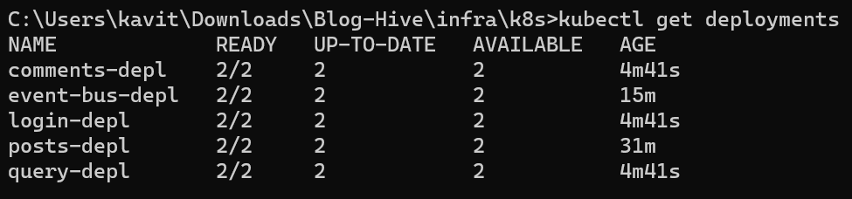

**3. Use Kubernetes Services:**

Create Kubernetes Services to expose each microservice internally within the cluster. Services allow microservices to communicate with each other using a consistent DNS name and IP address.

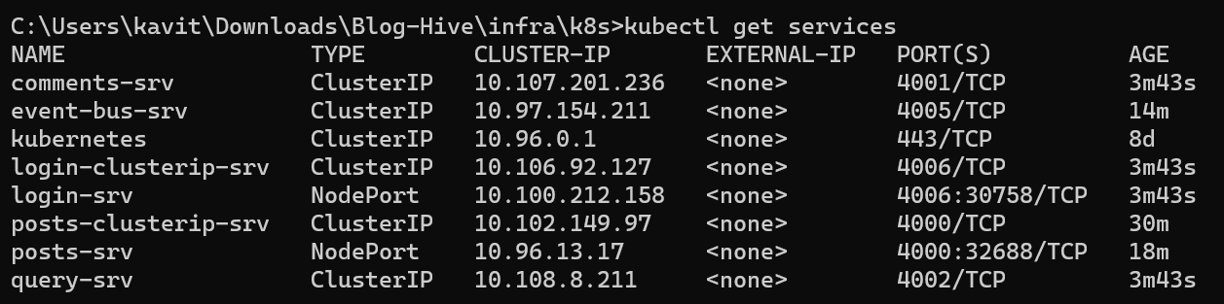

**4. Ingress for External Access (Load Balancing):**

Use Kubernetes Ingress to expose microservices to the external world. Ingress provides HTTP and HTTPS routing to services based on rules. Configure Ingress rules to route traffic to the appropriate microservices based on the path or host.

apiVersion: networking.k8s.io/v1

kind: Ingress

metadata:

  name: ingress-srv

  annotations:

    nginx.ingress.kubernetes.io/rewrite-target: /

spec:

  rules:

    - host: bloghive.com

      http:

        paths:

          - path: /signup

            pathType: Prefix

            backend:

              service:

                name: client-srv

                port:

                  number: 3000

          - path: /home

            pathType: Prefix

            backend:

              service:

                name: client-srv

                port:

                  number: 3000

          - path: /posts

            pathType: Prefix

            backend:

              service:

                name: client-srv

                port:

                  number: 3000

          - path: /posts/create

            pathType: Prefix

            backend:

              service:

                name: client-srv

                port:

                  number: 3000

          - path: /posts/?(.*)/comments

            pathType: ImplementationSpecific

            backend:

              service:

                name: client-srv

                port:

                  number: 3000

          - path: /

            pathType: Prefix

            backend:

              service:

                name: client-srv

                port:

                  number: 3000

**Describe how container orchestration simplifies deployment, scaling, and management.**

**1. Deployment:**

Declarative Configuration: Kubernetes allows you to define the desired state of your applications using declarative configuration files (YAML manifests). You specify how your application should run, including container images, resources, and dependencies.

Rolling Updates: Kubernetes supports rolling updates, enabling you to update your application without downtime. It gradually replaces old containers with new ones, ensuring continuous availability.

**2. Scaling:**

Horizontal Scaling: Kubernetes makes it easy to scale applications horizontally by adding or removing instances (pods) based on demand. This is achieved by adjusting the number of replicas in a Deployment or using the Horizontal Pod Autoscaler (HPA).

Auto-Scaling Groups: In cloud platforms like AWS, Kubernetes integrates with Auto Scaling Groups (ASGs). ASGs automatically adjust the number of nodes in a cluster based on resource utilization or custom metrics.

**3. Management:**

Automated Load Balancing: Kubernetes provides built-in support for load balancing, distributing incoming traffic across multiple instances of your application. This is crucial for high availability and fault tolerance.

Service Discovery: Kubernetes Services provide a stable DNS name and IP address for accessing a set of pods. This simplifies service discovery within the cluster, allowing microservices to communicate seamlessly.

**4. Health Checks and Self-Healing:**

Self-Healing: Kubernetes monitors the state of applications and takes corrective actions when needed. If a pod or node fails, Kubernetes automatically reschedules and restarts containers on healthy nodes.

**5. Rollback and Versioning:**

Rollback Strategies: Kubernetes supports different rollback strategies in case of failed deployments. If an update introduces issues, you can easily roll back to a previous version of your application.

Versioning with Deployments: Deployments in Kubernetes manage the rollout and rollback of application versions. This ensures consistency and makes it easy to manage different versions of your application.

**Deployment Process**

**Provide scripts or configurations for deploying the microservices on the chosen cloud platform.**

* Kubernetes Deployment YAMLs:

Defined a Kubernetes Deployment YAML file for each microservice. This includes specifying the container image, resource requirements, environment variables, and other settings.

* Service YAMLs:

Created Kubernetes Service YAML files to expose your microservices internally within the cluster. Define the service type (ClusterIP, NodePort, or LoadBalancer) based on your requirements.

* Ingress YAML:

For exposing my microservices to the external world, I created an Ingress YAML file. This file defines routing rules for external access and may include SSL/TLS configuration.

All the detailed configuration files, scripts, and documentation for deploying microservices on AWS with Kubernetes can be found in the GitHub repository for BlogHive. (link given at the end)

**Demonstrate the ability to deploy the application in a cloud environment consistently.**

Creating Nodes

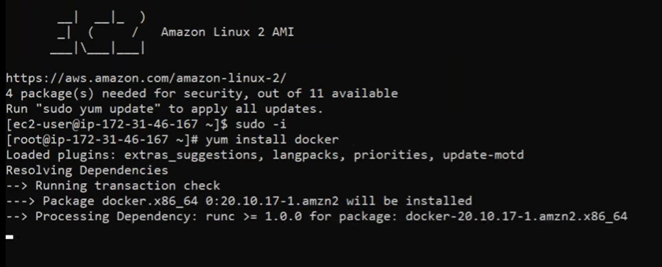

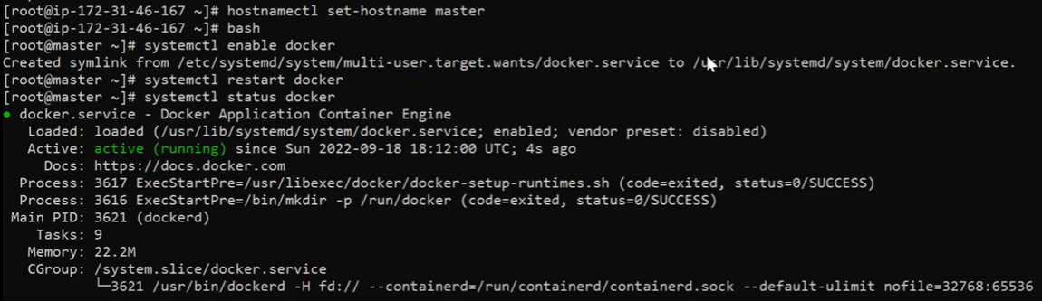

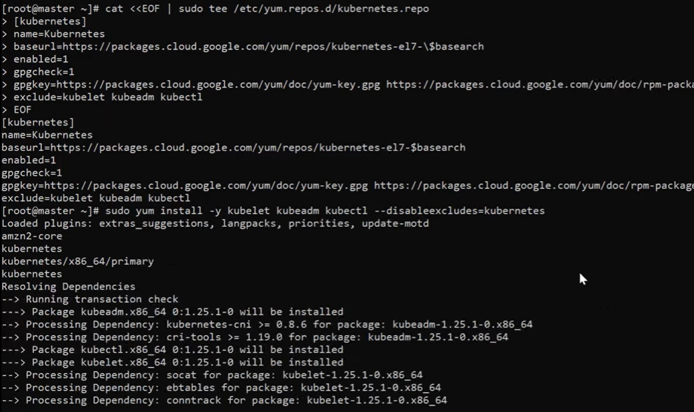

Repeat this process for each node.

Use token generated from master node to put in worker node

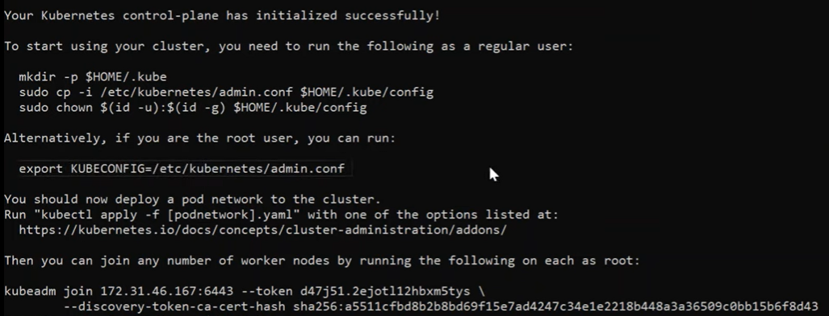

Creating Kubernetes Cluster using AKS

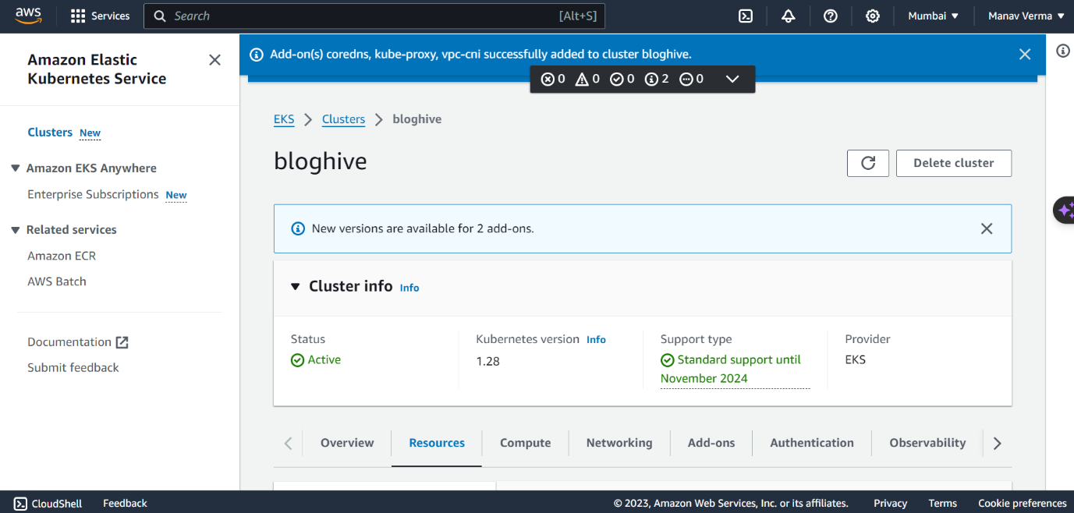

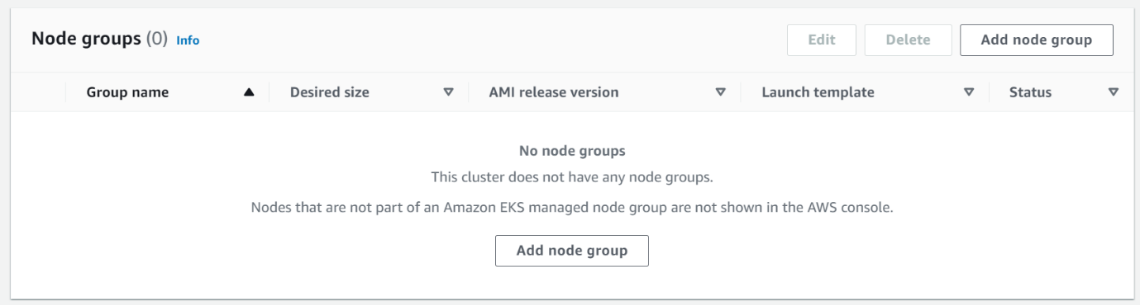

Step 1

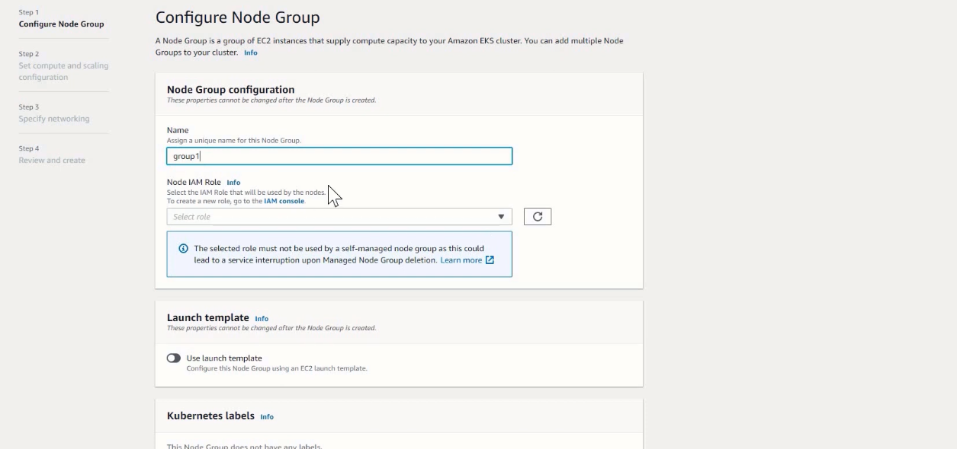

Step 2

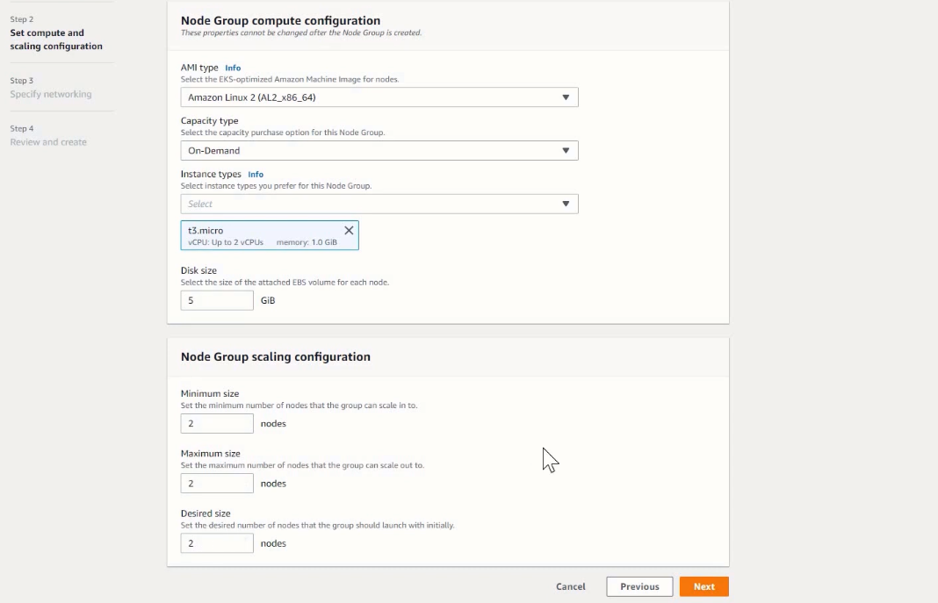

Step 3

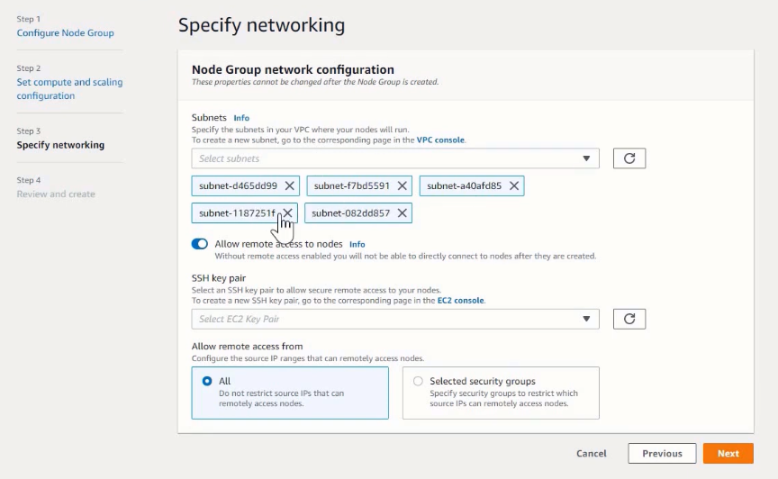

Node “group1” created

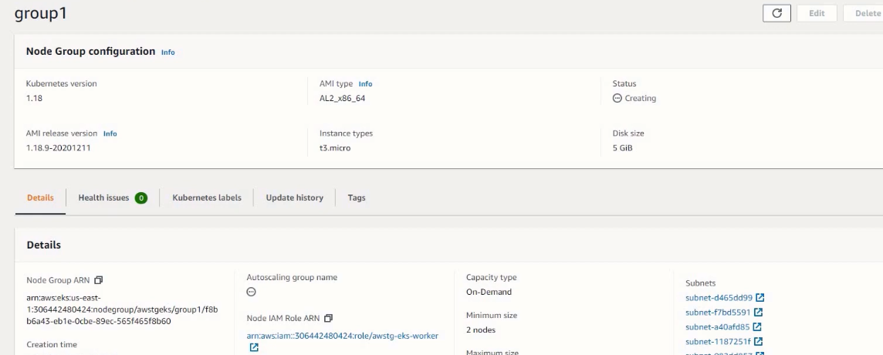

All pods in the node

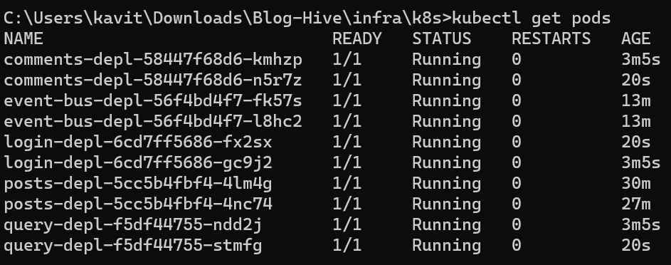

**Scaling and Load Balancing**

**Implement automatic scaling mechanisms for the microservices based on resource usage.**

**For posts service:**

apiVersion: autoscaling/v2beta2

kind: HorizontalPodAutoscaler

metadata:

  name: posts-hpa

spec:

  scaleTargetRef:

    apiVersion: apps/v1

    kind: Deployment

    name: posts-clusterip-srv

  minReplicas: 1

  maxReplicas: 10

  metrics:

  - type: Resource

    resource:

      name: cpu

      target:

        type: Utilization

        averageUtilization: 50

**For comments service:**

apiVersion: autoscaling/v2beta2

kind: HorizontalPodAutoscaler

metadata:

  name: comments-hpa

spec:

  scaleTargetRef:

    apiVersion: apps/v1

    kind: Deployment

    name: comments-clusterip-srv

  minReplicas: 1

  maxReplicas: 10

  metrics:

  - type: Resource

    resource:

      name: cpu

      target:

        type: Utilization

        averageUtilization: 50

**Explain how load balancing is achieved within the containerized environment.**

Load balancing within a containerized environment, particularly in Kubernetes, is achieved through the use of Ingress controllers. In Kubernetes, an Ingress is a resource that manages external access to services within the cluster. An Ingress controller is responsible for implementing the rules specified in the Ingress resource, which includes routing external traffic to the appropriate services and load balancing across multiple instances of those services.

When multiple microservices are deployed and exposed to external traffic, an Ingress controller plays a crucial role in distributing incoming requests among the available pods or instances of those services. Here's how load balancing is achieved within a containerized environment using Ingress controllers:

**1. Ingress Resource Definition:**

In Kubernetes, the application developer defines an Ingress resource, specifying rules for routing external traffic. These rules may include hostnames, paths, and backend services.

**2. Ingress Controller Implementation:**

An Ingress controller (e.g., Nginx Ingress Controller) is deployed in the cluster. The Ingress controller watches for changes to Ingress resources.

**3. Routing Decisions:**

As external requests enter the cluster, the Ingress controller evaluates the rules defined in the Ingress resource to make routing decisions. For example, it may route requests based on the hostname or path.

**4. Service Discovery:**

The Ingress controller interacts with the Kubernetes Service resources associated with the backend services. Services act as stable entry points, and the Ingress controller uses them for service discovery.

**5. Load Balancing:**

The Ingress controller employs load balancing algorithms to distribute incoming requests among the available instances of the backend services. This ensures that the workload is evenly distributed, improving application performance and reliability.

(For code check the github link)

**Monitoring and Logging**

In the deployment of microservices, establishing robust monitoring and logging practices is paramount to ensuring the optimal performance and reliability of the application. For monitoring, services such as Amazon CloudWatch can be employed to capture real-time metrics, including CPU utilization, memory usage, and network activity. By setting up custom CloudWatch Alarms, teams can receive timely notifications or trigger automated actions when predefined thresholds are breached, enabling proactive responses to potential issues.

In tandem with monitoring, logging mechanisms play a crucial role in troubleshooting and gaining insights into the microservices' behaviour. Leveraging CloudWatch Logs, developers can centralize log management and store logs generated by each microservice. Integrating CloudWatch Logs with additional tools like Amazon Elasticsearch and Kibana facilitates advanced log analysis, enabling efficient troubleshooting of issues and identification of performance bottlenecks. AWS X-Ray, a distributed tracing service, further aids in visualizing the flow of requests across microservices, allowing for in-depth performance analysis and identification of latency-related challenges.

The ability to monitor application performance and troubleshoot issues is not only about collecting data but also about utilizing these insights to iterate and optimize. Continuous refinement of monitoring and logging configurations ensures that the deployed microservices remain resilient, scalable, and responsive to evolving demands, ultimately contributing to the overall health and effectiveness of the application architecture.

To complement the explanations provided, I have included relevant code snippets, configuration files, and screenshots in a GitHub repository. This repository serves as a comprehensive resource, allowing for a deeper understanding of the implemented solutions. Code snippets, such as Kubernetes manifests and AWS CloudFormation scripts, are organized to reflect the architecture of the deployed microservices.

**Website**

Login page

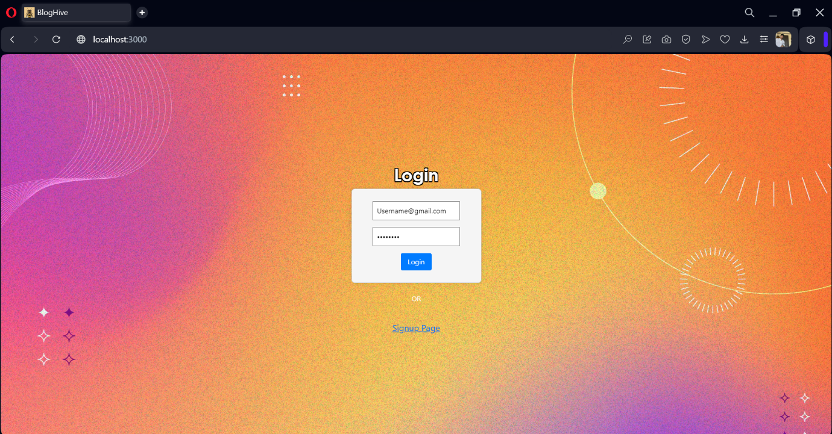

Redirecting page



Main page

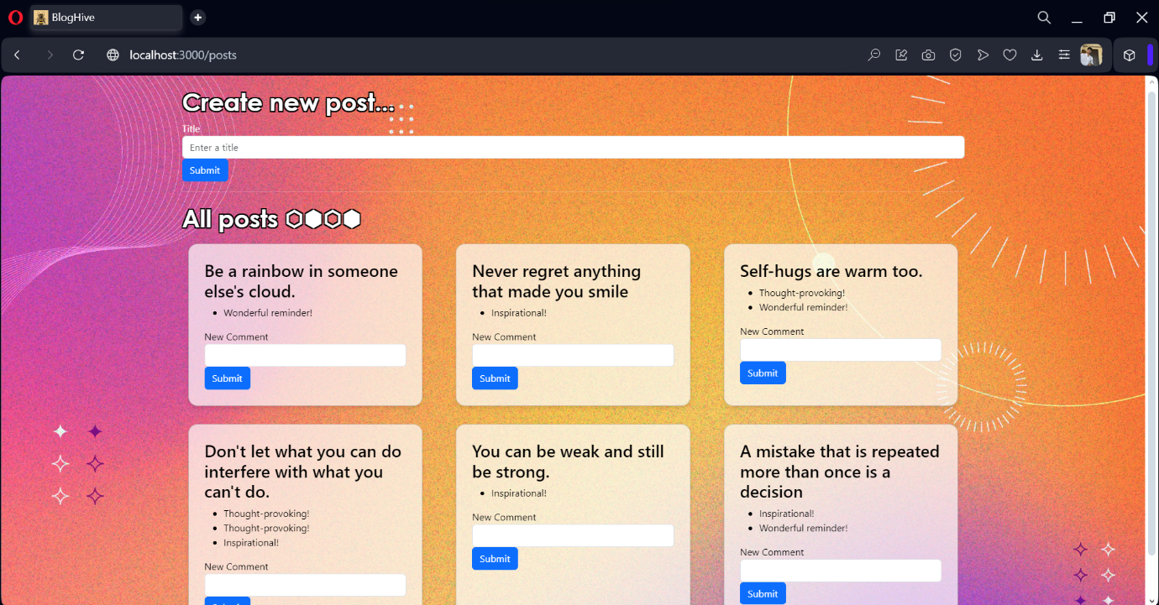

**GitHub Link:**

[**https://github.com/manavvrma/Blog-Hive**](https://github.com/manavvrma/Blog-Hive)